GENERAL READING TEST 28
SECTION 1Questions 1 - 14

Questions 1 - 7

Complete the table below.

Write NO MORE THAN TWO WORDS from the text for each answer.

Write your answers in boxes 1 - 7 on your answer sheet.

The Beaver Valley Hotel - Activities for Residents

ACTIVITY | NOTES
Horse Riding\ | * 10 minutes away
 | * (1) __________ available for adults and children
 | * Tours available with experienced (2) __________
 | * Different treks available
 | * Not too expensive
 | * Bookings at reception
Kayaking | * Hotel-owned kayaks for 1 or more people
 | * Map, (3) __________ and advice supplied by hotel
 | * 3 possible length kayak trips available
 | * Set down and pick up supplied
 | * Free for residents
 | * Bookings at reception
Hiking | * Variety of difficulty
 | * Maps and advice provided on stops for (4) __________
 | * Range from short to whole day
The Local Volcano | * 7 miles away
 | * Cone-shaped hill is extinct volcano
 | * Moderate climb with (5) __________ for rests
 | * (6) __________ provide formation and history details
 | * Great view - even the distant mountains can be spotted sometimes
 | * Return travel by bus is very easy
Flea Market | * 7 a.m. start
 | * Pick up a bargain
 | * Plenty of cafés and restaurants

Check the (7) __________ before you go on any outings!

The Beaver Valley Hotel - Activities for Residents

In our location in the Beaver Valley, we are lucky to have so many possibilities for things to do. Here is a taster of some of our favourites.

For those of you interested in horse riding, we are in partnership with a local riding club. Just 10 minutes drive away from the hotel, John will give you a wonderful time with his fantastic team of horses. They offer various things. You can get lessons for yourself and/or your child, or you can take a guided trek into the local forests and hills. You’ll be taken for up to four hours around the local area to see the wonderful countryside and hopefully lots of the local animals. There are various sights to take in, such as castles, and John’s guides know the area well and exactly where to go. If you enjoy it, the riding centre has various routes to offer, so, if you’re not too stiff, you can do a different trek later in the week. They’re very reasonably priced, so ask us at reception to give John a call to make a booking.

As we are next to the Beaver River, we decided to buy a range of one-person and two-people kayaks. We’ll take you to a good starting point on the river and give you a map, so you know where you’re going. For safety, there are life vests provided and we’ll give you some hints on kayaking. Then, after two, four or six hours, we’ll pick you up at pre-arranged points. The river never flows that fast and is not deep, so this is a safe outing for all the family. This activity is free of charge for residents of the hotel, so come to reception again to make a booking.

If horses and water are not your thing, there are lots of hiking trails, which range from easy to demanding. We have plenty of maps of the trails and advice on places to pause for refreshments. Hikes vary from a one-hour stroll to all-day walks that will tire you out and sharpen your appetite for dinner.

About seven miles from the hotel, you may have seen a modestly-sized conical hill. It’s a local secret that this hill is actually an extinct volcano from millions of years ago. It’s been eroding all that time, so it’s not that difficult a climb and there are well-tended paths with benches on which to take a break. In addition, there are lots of information boards scattered around, so that you can learn about the formation of the volcano and its history. When you reach the top, there is a magnificent view and, on a clear day, you can even see the distant mountain range. Buses leave from outside the hotel every hour, on the hour, and return with the same frequency.

Every Sunday, the local market town holds a flea market. It begins at 7 a.m., so get up and get there early to see if you can pick up a bargain. The market square also has lots of cafés and restaurants, so if you’ve done enough browsing, you can make yourself comfortable and sip a tea, coffee or cold drink.

As you can see, lots of our activities are outside, so make sure you inform yourself regarding the weather forecast to avoid getting too wet (if that bothers you!).

Questions 8 - 14

The text on the following page has 7 sections (A – G).

Choose the correct heading for each section from the list of headings below.

Write the correct number (i – x) in boxes 8 – 14 on your answer sheet.

 | I . | Exchanging your Old Printer
 | Ii . | Running out of Ink
 | Iii . | Starting to Print
 | Iv . | Troubleshooting
 | V . | Safety Instructions
 | Vi . | Printing Materials
 | Vii . | Positioning your New Printer
 | Viii . | How to Clear Blockages
 | Ix . | Printer Maintenance
 | X . | Using Coloured Inks

8 . Section A

9 . Section B

10 . Section C

11 . Section D

12 . Section E

13 . Section F

14 . Section G

Using your New Electronix Printer

A . Your new Electronix printer is an electronic device and you should therefore always observe some basic precautions: connect your printer to properly grounded electricity outlets, replace any damaged or frayed cables, don’t open or try and fix your printer yourself, and unplug your printer whilst replacing the ink cartridge.

B . Do not block or cover the openings in the printer’s cabinet. Keep your new Electronix printer away from excessive direct sunlight and put it on a secure table that will not fall over easily. Put your printer in a place away from children.

C . When you connect your new Electronix printer to your computer, you should be able to print straight away, as most computers have all common printer software already installed. If you cannot print, you will be able to find the driver software online or on the CD that is provided with your new Electronix printer.

D . Your new Electronix printer will work with all sizes of standard printer paper. Do not use any metallised paper in it, as this will not work. Do not try and print using any plastic sheets or plastic coated paper. Your new Electronix printer uses heat in its printing process, which will melt any plastic used.

E . Your ink cartridge can be replaced at most reputable high street dealers or you can order one online on our website. Consult your instruction manual or our website for instructions on how to replace your cartridge. Using a different brand of ink in your new Electronix printer will invalidate your warranty.

F . Your new Electronix printer does not require any servicing, but cleaning it periodically can extend its life and performance - a good time for doing this can be when you’re changing your ink cartridge. Use only soft tissues or a soft brush for cleaning and don’t use any chemicals.

G . If your printer malfunctions in any way, check our Problems with your Printer guide that is available on our website. Follow the instructions given there. We have found that 80% of customer problems are resolved using our guide. If there are still problems after using our guide, go to one of the recommended repair outlets that are also available on our website.

SECTION 2 Questions 15 – 27

Questions 15 – 21

Complete the flow chart below. Write NO MORE THAN THREE WORDS from the text for each answer. Write your answers in boxes 15 – 21 on your answer sheet.

Our Employee Appraisal Process

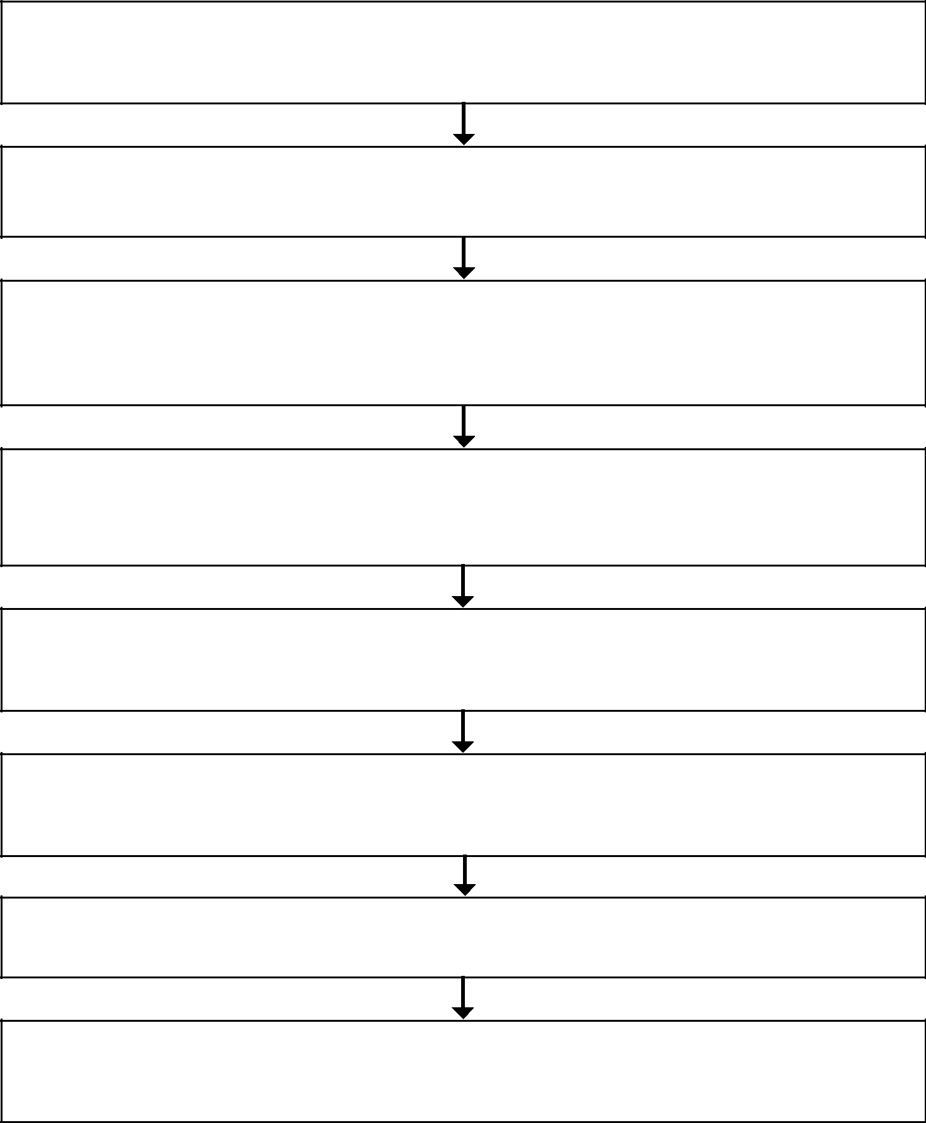
- The Interview The job description used at the employee’s original interview will outline the roles and responsibilities; these will be formalised in the employee’s (15) _________.

    - 3-month Review This ends the employee’s (16) _________ and ensures things are going smoothly.

  - Before the Annual Meeting (17) _________ of the annual meeting should be given 2 weeks before, so that the employee can prepare and submit a (18) _________ covering

four key points.

- The Meeting Appropriate time should be set aside and it should be fairly (19) _________

to create an effective atmosphere. The meeting will discuss what the employee submitted

before the meeting.

    - The (20) _________ (part of the meeting) Although the employee gives input, the manager alone awards this.

- The Report This will be written by the manager and sent to the employee within a week of the meeting.

  - The Second Meeting The report is discussed and signed by manager and employee.

- Appeal If desired, employees can use the appeal process laid out in the (21) _________.

Our Employee Appraisal Process

Employees in our organisation are clearly engaged in their work and doing their best for our organisation. In order to recognise employees’ commitment, we run an annual appraisal program. In a way, the program begins with when an employee is interviewed for his/her job. The job description will have outlined the roles and responsibilities of the employee’s position. The contract will then stipulate these things officially.

The appraisal process of an employee should begin a year after the employment began with the first annual review, although there will be a 3-month review of the employee at the conclusion of the probation period. The three-month review allows both employer and employee to be sure that their commitment to each other is warranted.

Before the annual meeting, the employee should receive at least two weeks’ notice. The employee should give a self-evaluation statement to the manager(s) conducting the meeting giving his/her views of his/her performance over the year in terms of the roles and responsibilities. He/she should note:

- what things are perceived to have gone well over the year

- what things should have gone better over the year

- how things should be improved over the next year

- potential targets in the coming year for the company and the employee’s personal growth

There should be plenty of time allocated to the appraisal meeting. It should be reasonably informal, so that the employee is at ease and can discuss his/her performance without any undue pressure. The agenda of the meeting will follow the four points referred to above.

At the end of the meeting, there will be a rating of the employee’s performance. The employee will give his/her input regarding this, however, awarding it will be the sole responsibility of the manager(s) conducting the appraisal. The employee will be outstanding, standard or unsatisfactory.

After the meeting, the manager will write up a report and present it to the employee within a week. The rating will be included within this report. There will then be a second meeting with the employee to discuss this report to ensure that it is fair and then both the manager and the employee should sign it when they are happy with it. The report will form a basis for the following year’s annual appraisal meeting. If there is any conflict over the report, then there is an appeal process for the employee. Employees should consult the company handbook to inform themselves about this process.

Questions 22 - 27

Complete the sentences below.

Write NO MORE THAN THREE WORDS from the text for each answer.

Write your answers in boxes 22 - 27 on your answer sheet.

22 . Domestic and work _____________ can become unclear due to social media usage.

23 . An excessively formal social media policy at work could be an _____________ step.

24 . The _____________ nature of social media developments means that social media

policies can easily become out of date.

25 . It can be _____________ to check the social media pages of potential employees.

26 . Anyone in the workplace should often check their social media _____________ to stop

unwanted access to their private life.

27 . Employers should consider the _____________ of their employees when dealing with the

sensitive issue of social media in the workplace.

Using Social Media in Companies – a guide for companies, workers and unions

The impact of social media on the workplace is increasing. Social media is the broad term for internet-based tools used on PCs, laptops, tablets and smart phones to help people make contact, keep in touch and interact. This trend can affect communications among managers, employees and job applicants, how organisations promote and control their reputation, and how colleagues treat one another. It can also distort what boundaries there are between home and employment.

Key Points

Develop a policy: Employers should include what is and what is not acceptable for general behaviour in the use at work of the Internet, emails, smart phones and social media, such as networking websites, blogs and tweets. However, it might prove impractical to have an overly formal policy that also includes rigidly covering the use of social media in recruitment.

Rules for recruitment: While a rigid policy on using social media in recruitment could soon become obsolete, because the trend is so dynamic, it is still advisable for an employer to have at least some rules, or procedures, which managers and employees should follow.

Screening job candidates: In particular when recruiting, employers should be careful if they assess applicants by looking at their social networking pages, as this may be discriminatory.

Who can see profiles? Employees should regularly review the privacy settings on their social networking pages, as they can change. Also, they should consider whether they want or need co-workers to see those profiles.

Talk to staff: Employers should inform and consult their employees if planning to monitor social media activity affecting the workplace.

Update other policies: For example, an organisation’s policy on bullying should include references to ‘cyber bullying’.

Be sensitive: Employers should promote a work-life balance - the line between work and home is becoming increasingly blurred by the use of modern technology.

SECTION 3 Questions 28 - 40

Read the following passage and answer Questions 28 – 40.

The horse used to be an indispensable part of human life and it was used for transport, war, industry, and for fun. In order to support society’s dependence on the horse, whole industries grew up around it. There were sectors to breed them, shoe them, saddle them, teach people to ride them, feed them, care for them, and finally to dispose of them at the end of their useful lives. The industrial revolution and in particular the invention of the internal combustion engine was the end of the horse’s central role in people’s lives. Today, it seems there is a further threat to the horse that is causing a drop in its numbers. The American Horse Council (AHC) recently addressed this decline at its National Issues Forum. Leaders from various stakeholders spoke about the decrease in registered horses and the impact on their segment of the horse industry.

There has been an enthusiastic response to the forum’s discussions. “People have been talking about the decline in horse numbers for some time, however, this is the first time the issue has been discussed in a comprehensive fashion,” said AHC president Jay Hickey. “It was a very good program and attendees now have a better comprehension of current conditions and what actions are being taken.”

Tim Capps, Director of the Equine Industry Program at the University of Louisville, gave the opening address at the forum and tried to pinpoint the reasons for the drop in today’s numbers of registered horses. The economy was cited by Capps as the single largest factor, but there are probably several other factors as well. Capps believes the horse industry was in a bubble that peaked about six years before, which was similar to an earlier bubble in the 1980’s. The bubble burst and caused the resulting damage to the horse industry. Capps also cited the roles of the increasing cost of horse ownership and participation in shows, concerns about welfare, and increased competition for leisure and gambling dollars.

In addition, Capps explained that there has been a decline in the number of young horses and registered horses over the last several years that is impacting all breeds and segments of the industry and the leaders of the industry are aware of this decline and are taking action. Capps also noted that this is not the first such decline in the number of horses, and in previous instances there was later a strong rebound in numbers. Examples of this were most notably during the Great Depression and in the mid-1980s. Capps pointed out the horse industry often parallels the wider economy and the current situation closely mirrors the impact the Great Depression had on the industry. In the past, the growth following such declines was often propelled by individuals outside the industry becoming interested and investing in the industry, noted Capps. He believes it will again be important to look beyond current horse industry participants to promote growth in the industry now and in the future.

Jim Gagliano, Jockey Club President, reported on the effects of the drop in numbers on the horse racing industry. “The thoroughbred foal crop has been declining and is responsible for a drop in the number of starts, number of horses in the field, the number of owners, and the number of racing days. This in turn has led to a drop in turnover for all sectors in the industry and makes the industry a less attractive one for new entrants and existing businesses.” Forum attendees also heard what actions are being taken by the racing industry. Mr. Gagliano said that organisations are working to promote the best races and make better use of social media and online resources to attract a younger demographic, and develop new owners.

Following up on the need for more and better marketing, Patti Colbert of PCE Enterprises

has come up with the Time to Ride initiative. This ambitious national campaign and contest targets the goal of giving 100,000 new people a horse experience in the following calendar year. Ms. Colbert reported that Time to Ride had accomplished its initial goal to sign up 1,000 stables, instructors, new participants and others in the horse community to host events. Colbert enthusiastically explained the next step. “These hosts will now compete for $100,000 in cash and prizes and several have already hosted their first event.”

The forum also heard from associated service providers who are also being impacted. Jeff Blea, President of the American Association of Equine Practitioners (AAEP) talked about the impact on the veterinarian community and how fewer horses mean less work for horse vets. Blea additionally spoke about the AAEP programs to help veterinarians create long-term and successful relationships with horse owners and support an increase in horse breeding.

The forum has clearly identified that the problem is not only a decline in the number of registered horses, but also a decline in horse owners and people participating in horse activities. However, there is also good news, as industry organisations are taking action both individually and collectively. Hickey explains why people are not overly worried just yet. “The industry also has one great advantage: the enduring appeal of the horse. With continued effort on the part of the entire horse community, the industry will come out of the current economic climate even more robust.”

Questions 28 - 35

Look at the following statements (questions 28 - 35) and the list of people below.

Match each statement with the correct person’s initials.

Write the correct initials in boxes 28 - 35 on your answer sheet.

28 . The poor economic conditions in the horse industry are discouraging the starting of new
horse-related businesses.

29 . The strength of the horse industry often reflects the prevalent economic climate.

30 . Participants at the American Horse Council National Issues Forum now have an improved

understanding of the issues challenging today’s horse industries.

31 . Recent promotion has already led to more people being introduced to horse riding.

32 . Organisations related to the horse industry are improving their use of modern digital

marketing.

33 . Today’s horse industries will emerge from the slump even stronger than they were before.

34 . Vets are also involved in helping in movements to increase the numbers of horses being

born.

35 . The lasting fascination that people have with the horse will be one reason that the

industry will recover.

JH Jay Hickey

TC Tim Capps

JG Jim Gagliano

JB Jeff Blea

PC Patti Colbert

Questions 36 - 39

Do the following statements agree with the information given in the text below? In boxes 36 – 39 on your answer sheet write:

 | TRUE |  |  | if the statement agrees with the information
 | FALSE |  |  | if the statement contradicts the information
 | NOT GIVEN |  |  | if there is no information on this

36 . The industrial revolution created an increase in the numbers of horses required in industry

and transportation.

37. The horse industry has reacted well to previous drops in the number of horses.

38 . The current decline in horse numbers is still a reaction to the economic slump in the

1980’s.

39 . The Time to Ride movement has gained political as well as industry support.

Question 40

Choose the correct letter, A, B, C or D.

Write the correct letter in box 40 on your answer sheet.

40 . What is the writer’s purpose in the text in section 3?

A . To explain why the American Horse Council is the best organisation to deal with the

expansion of the horse industry.

B . To review initiatives addressing current challenges to the horse industry.

C . To describe the historical decline of the horse.

D . To summarise organisations devoted to the welfare of the horse today.

