SECTION 1 QUESTIONS 1-10
Questions 1—4
Complete the schedule below.
Write NO MORE THAN THREE WORDS for each answer.
Example: Cioloetrotters Language School
Class Schedule
Chinese
Level: Advanced
Days: 1 ________________ evenings
Japanese
Level: 2 ________________
Days: Tuesday and Thursday mornings

Level: 3 ________________
Days: Monday, Wednesday, and Friday mornings
French
Level: Intermediate
Days: Friday 4 ________________

Questions 5—8
Complete the information below.
Write NO MORE THAN ONE NUMBER for each answer.
Tuition Information
One week 5 $ ________________
Four weeks 6 $________________
Six weeks 7 $ ________________
Twelve weeks 8 $ ________________

Questions 9 and 10
Complete the sentences below.
Write NO MORE THAN THREE WORDS for each answer.
9 Students can register for a class by visiting_______________.
10 ________ is in charge o f student registration.
SECTION 2 QUESTIONS 11-20
Questions 11—15
Label the map below.
Write the correct A-J, next to questions 11—15.
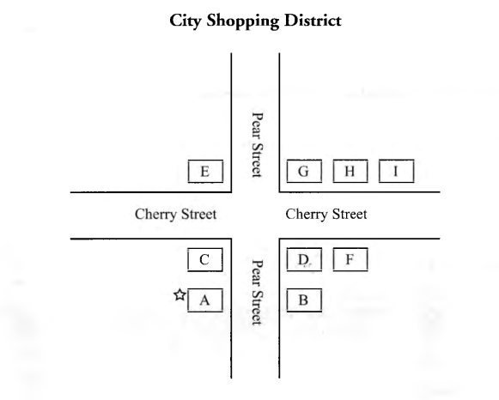
11 Harbor View Bookstore
12 Pear Cafe
13 Souvenir Store
14 Art Gallery
15 Harbor Park
Questions 16 -2 0
Complete the sentences below.
Write ONE WORD ONLY for each answer.
Harbor Park
16 The park was built i n ________________ .
17 A ________________ stands in the center2 o f the park.
18 Take the path through t h e ________________ .
19 In the middle o f the garden is a ________________ .
20 A ________________ takes you down to the harbor and a view o f the boats.
SECTION 3 QUESTIONS 21 -30
Questions 21-24
Complete the information about the archives
Write NO MORE THAN THREE WORDS AND /OR A NUMBER for each answer.
Welcome to City Archives
The following people may use the archives:

• University students with a valid 21 ________________
• City residents with payment of 22 ________________
• All others: Special permission from the director is required.

Hours:
Days: 23 _____________ through_____________
Hours: 24 9:30 A.M. until _____________P.M.

Questions 25 —3 0
What can be found on each floor of the archives building?
Write the correct letter, A—G next to questions 25—30.
CITY ARCHIVES
A nineteenth-century documents
B maps
C personal papers
D photographs
E books about the city
F newspapers
G information about the woolen mill

Floor of the building
25 basement __________________
26 ground floor ________________
27 second floor ________________
28 third floor __________________
29 fourth floor _________________
30 fifth floor ___________________
SECTION 4 QUESTIONS 31-40
Questions 31 -33
Complete the notes below.
Write NO MORE THAN TWO WORD S for each answer.
Historical Uses o f Wind Power
Ancient China Windmills were used to 31___________________
Ancient Persia Farmers used wind power to 32_______________
The Netherlands People used windmills to 33________________

Questions 34-40
Complete the chart below.
Write NO MORE THAN TWO WORDS for each answer.
WIND POWER
ADVANTAGES | DISADVANTAGES
Unlike oil and coal, wind power does not cause 34________________  There are limited supplies of oil and coal, but wind is a 35___________  It 36 ___________ to generate electricity with the wind.  Wind turbines do not take up much land. | The cost of the initial investment is high.  The 37 __________ of the wind the constant .  Wind turbines are usually located far  from 38____________  Wind turbines may spoil 39 __________  Wind turbines are as 40 _________as a high-speed car.

